# RBC Churn Analysis

Presented by: Ankita Pall, Kajal Malik, Sai Sahu

Motivation:

To minimize the customer churn and to improve the client base and to provide insights to help the bank develop loyalty programs and retention campaigns to retain as many customers as possible.

We have used trend analysis and risk associated with customer to identify the chances that customer will migrate to another bank.

Overview: 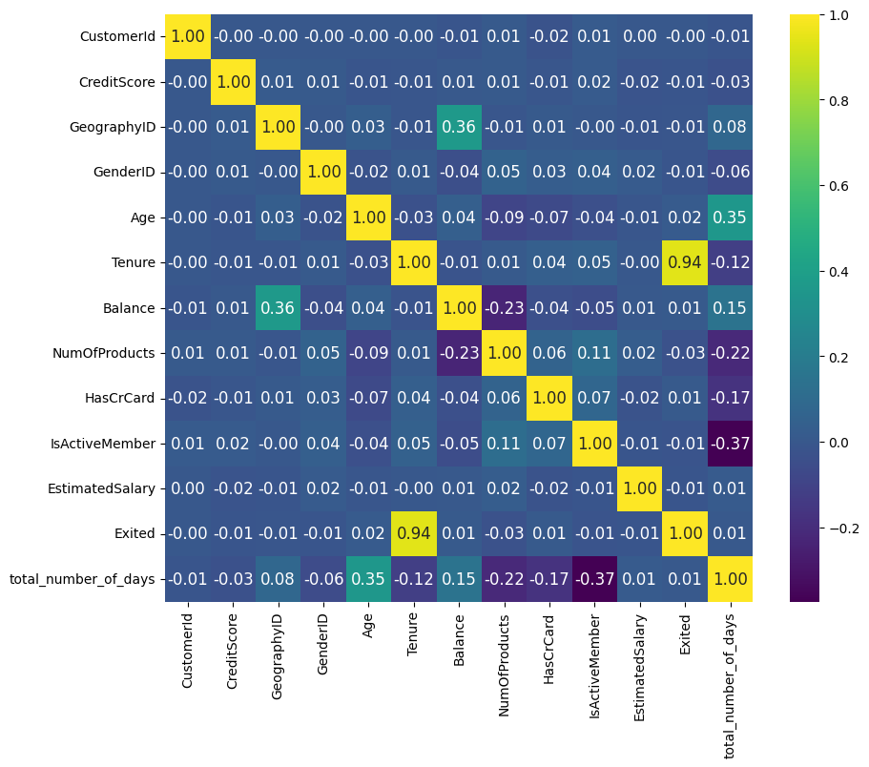

Research Questions

Methods

|  |  |  |  |  |
| --- | --- | --- | --- | --- |
| ML Algorithms | Accuracy | Precision | Recall | F1 Score |
| KNN | 0.595 | 0.576 | 0.644 | 0.608 |
| Logistic Regression | 0.655 | 0.640 | 0.670 | 0.655 |
| Gaussian Naive Bayes | 0.715 | 0.687 | 0.762 | 0.723 |
| Decision Tree Classifier | 0.773 | 0.759 | 0.784 | 0.771 |
| Random Forest Classifier | 0.855 | 0.847 | 0.856 | 0.852 |
| Gradient Boosting Classifier | 0.834 | 0.836 | 0.820 | 0.828 |

Result/Conclusion